**Upload Image To IBM Container**

|  |  |
| --- | --- |
| **Team ID** | PNT2022TMID27677 |
| **Project Name** | Smart Fashion Recommender Application |

**CREATING REPOSITORY IN IBM CLOUD:**

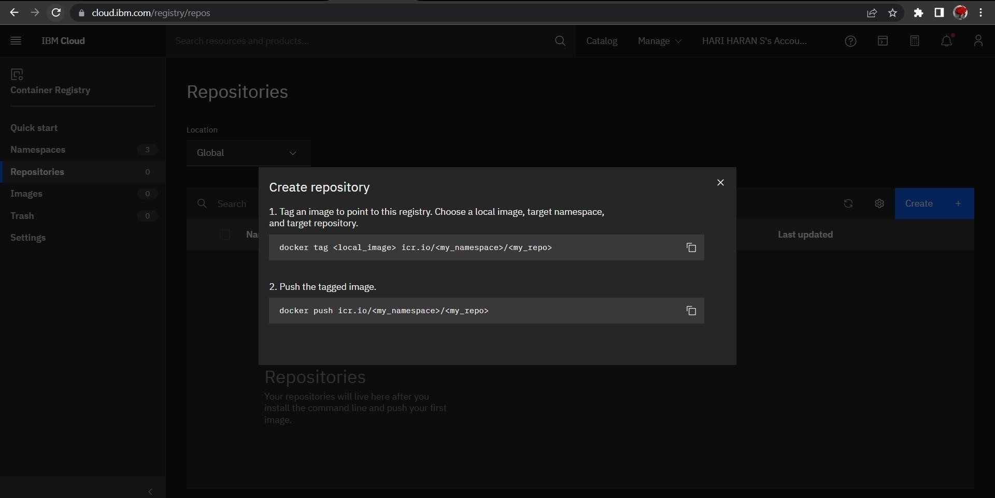

**UPLOAD IMAGE TO IBM CONTAINER REGISTRY:**

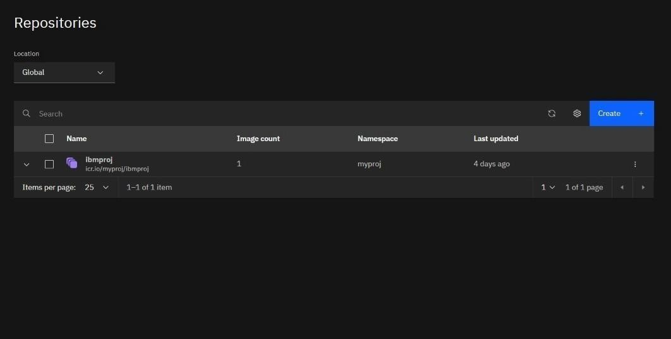

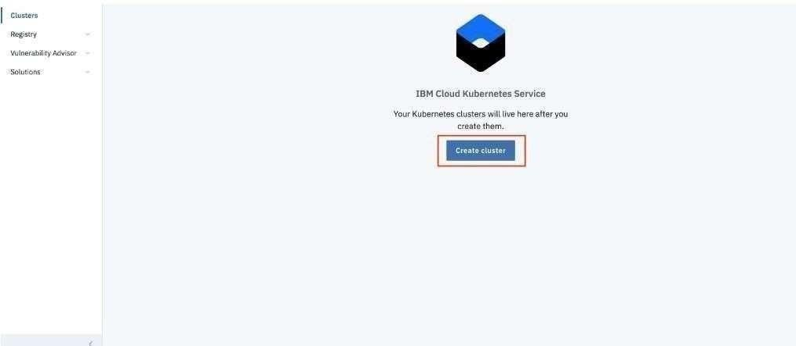

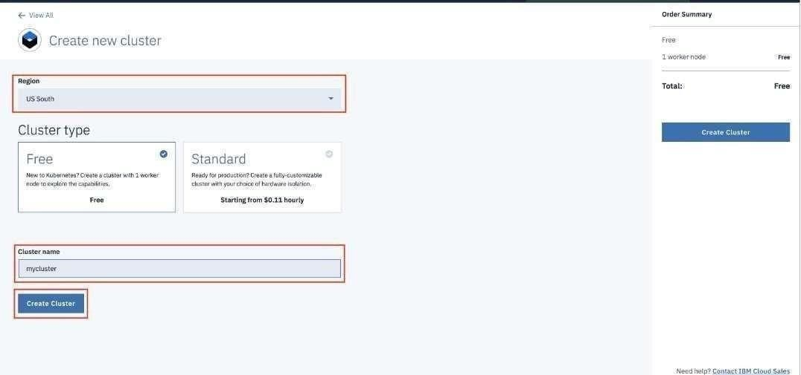

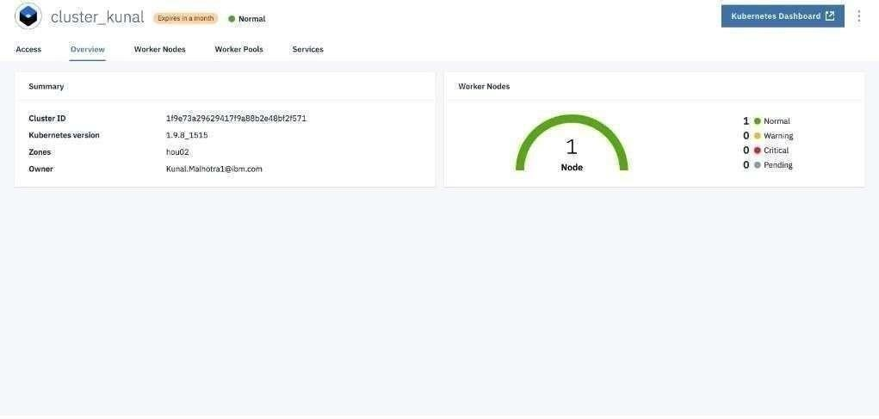

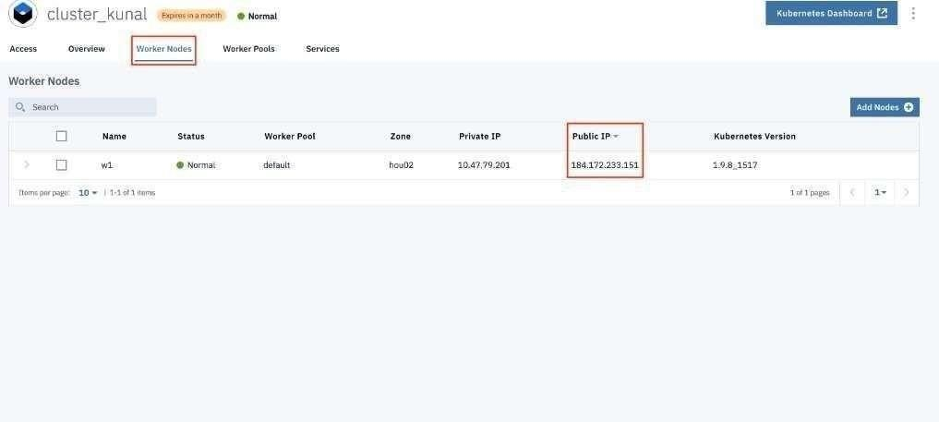

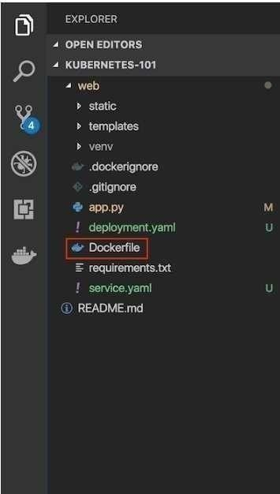

**DEPLOY IN KUBERNETES CLUSTER**

